Date: February 5, 2026

Participants: John Manavalan (Grade 11)
Harshad Maganuru (Grade 11)

High School: Metea Valley High School (Aurora, Illinois)
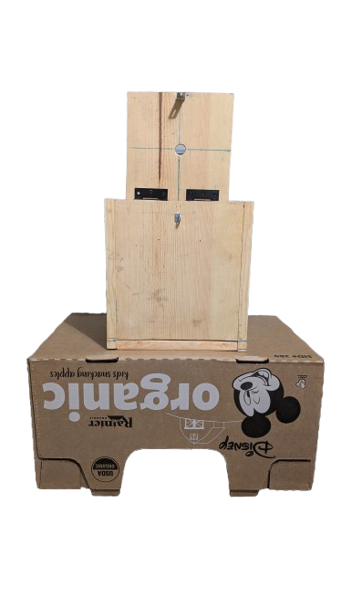
SmokeSmart Disposal

Introduction:

Cigarette litter is not just a nuisance, but a harmful issue that is threatening the vibrant communities of Illinois. As smokers finish their cigarettes, instead of responsibly disposing of them at their homes or in public ashtrays, they leave these cigarettes to burn on the floor or in the soil, causing significant harm to the environment we live in. A study conducted by the Loyola University of Chicago has revealed that "cigarette butts are still the most common kind of litter found at city beaches in Chicago" (Wong). A team from Loyola University collected 57,066 pieces of litter — nearly a ton — April through October from 2003 to 2014 at Ohio Street Beach in Chicago. "Of that total, 41.9 percent of items collected were cigarette butts, even though smoking has been prohibited along the lakefront since 2007 and in all city parks since 2014" (Wong). This is a problem that needs our immediate attention and action.
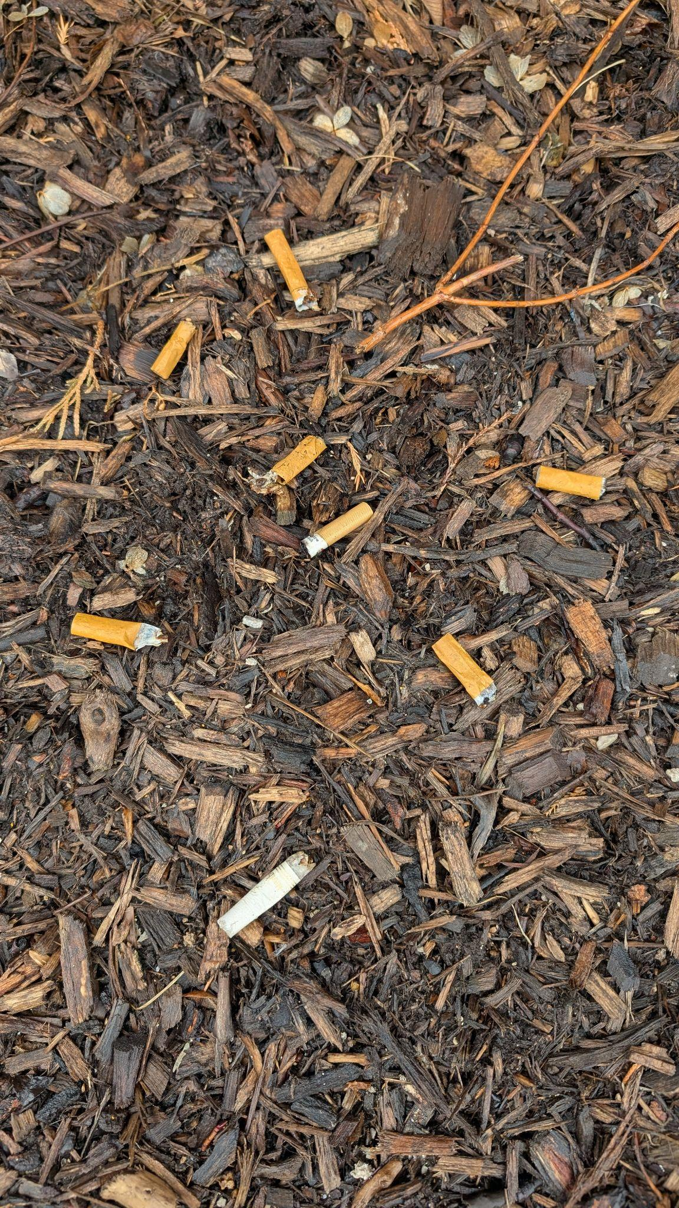
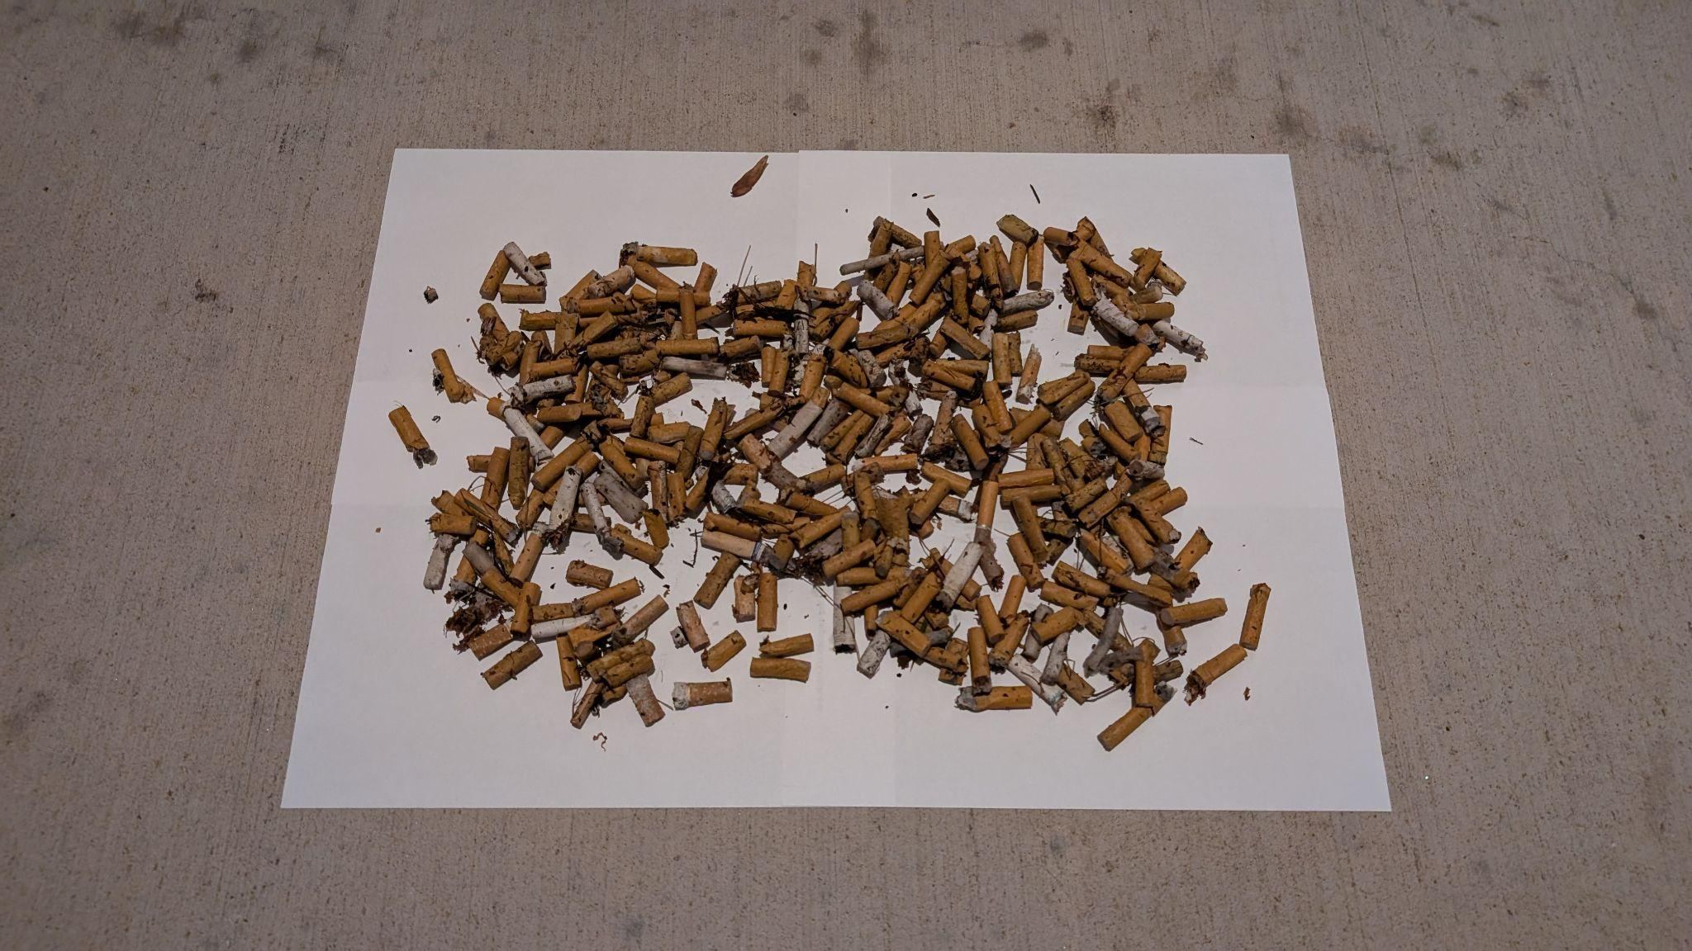
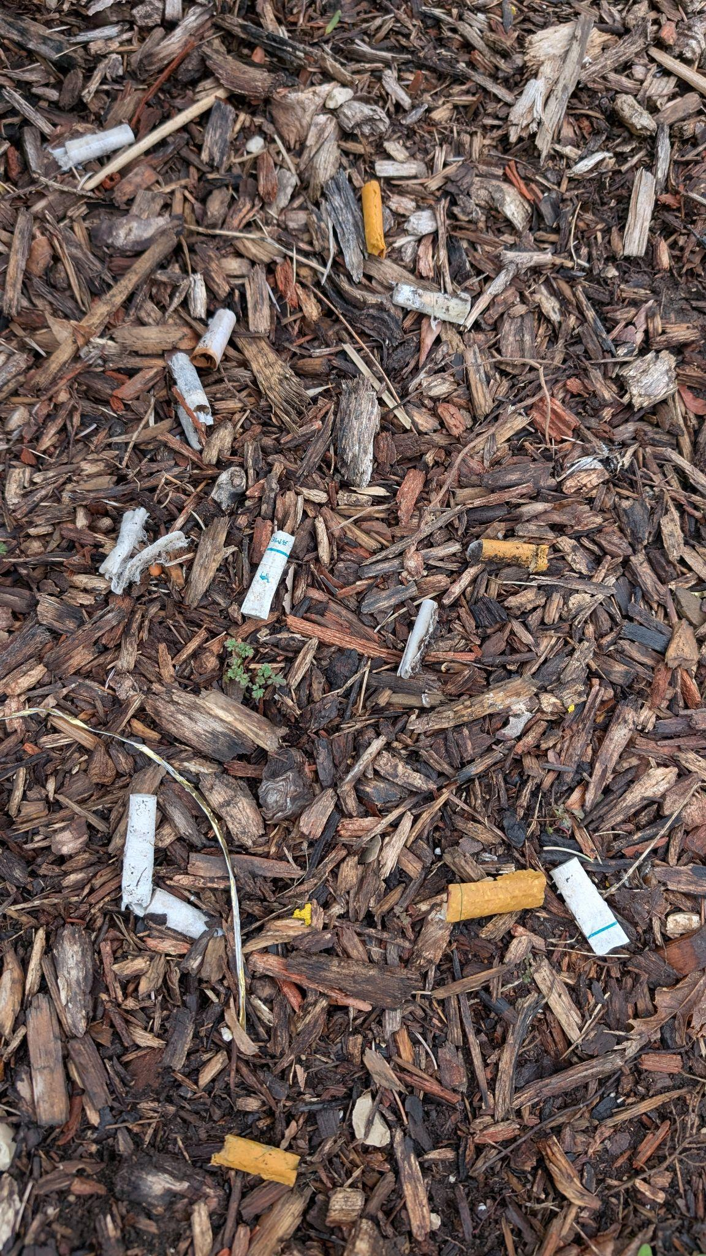
]

Litter from Station Boulevard Park Naperville Downtown Riverwalk Litter
(Collected in 15 mins.)

We noticed that in shopping plazas, although ashtrays and trash cans were still properly used by these smokers, these containers often started overflowing with cigarettes with no one to clean them up, causing the used cigarettes to emit toxic chemicals into the atmosphere. This cigarette pollution is damaging not only the lungs of smokers but also the lungs of civilians due to secondhand smoke exposure. As a result, we created a new and sustainable SmokeSmart Disposal system. The SmokeSmart Disposal system is a cigarette disposal device that makes it easy for smokers to dispose of their used cigarettes and for garbage collectors to maintain and clean. Additionally, our device has been designed to prevent the vapors of used cigarettes from polluting the Earth.

Citations:
- Wong, Grace. “Cigarette Butts Make up Nearly Half of Trash at Chicago Beaches, Study Shows.” Chicago Tribune, 26 Dec. 2016, www.chicagotribune.com/2016/12/26/cigarette-butts-make-up-nearly-half-of-trash-at-chicago-beaches-study-shows/.
- Novotny, Thomas, et al. “Cigarettes Butts and the Case for an Environmental Policy on Hazardous Cigarette Waste.” International Journal of Environmental Research and Public Health, vol. 6, no. 5, 20 May 2009, pp. 1691–1705, www.mdpi.com/1660-4601/6/5/1691, https://doi.org/10.3390/ijerph6051691.

Methodology & Planning:

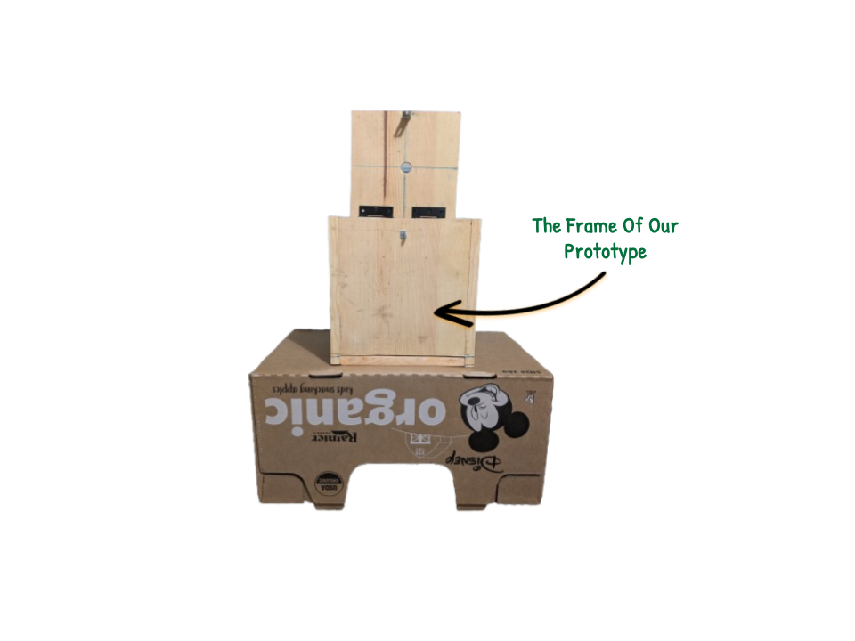
We started designing the prototype of our device in February. With this device, we wanted to make cigarette disposal easy and accessible for smokers in Illinois. Finding a way to absorb all of the harmful chemicals of a used cigarette and making sure these vapors don't leave our box and pollute the air was a difficult obstacle to overcome. We decided to make a disposal system where the user would drop the used cigarette into a box filled with a diluted solution of vinegar and water, thoroughly soak it, and absorb its toxic contents. For convenient maintenance, we plan to quickly add a plastic net to filter the cigarettes from the solution and a valve at the bottom to remove the contaminated water and replenish it with clean water using a hose from the top of the box. Furthermore, to ensure no water leakage, we have applied several coatings of waterproof sealant on the wood and water-resistant putty on the corners and edges. The features of our disposal system are labeled in the image below:
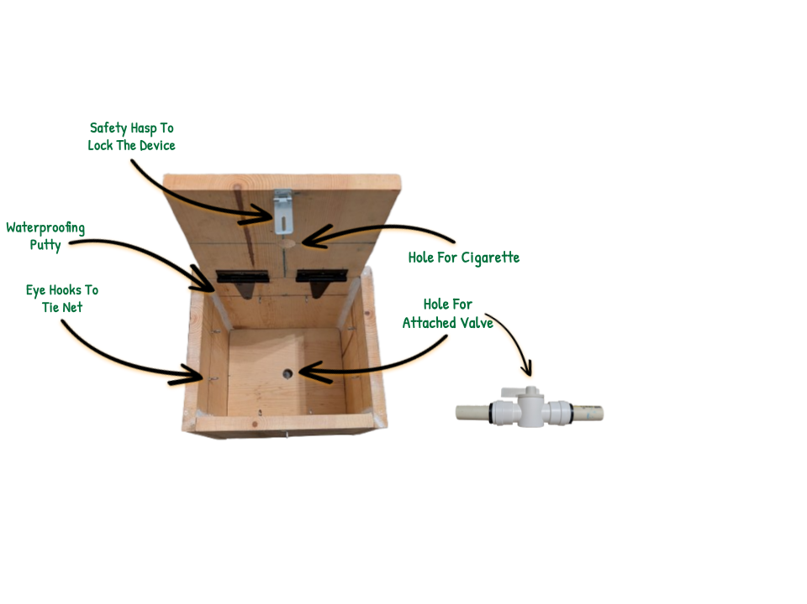

During this project, we spent a reasonable amount of money split among us (SEE MORE IN Budget). We visited home improvement retailers near us, like Home Depot and Menards, to buy our parts, like the wood and the valve. We had many drilling tools and saws, which made cutting and screwing the materials very convenient. Both of us s This project was rewarding for both of us as we learned much about woodworking and gained valuable hands-on experience, which will benefit our future projects.

Next Steps:
We have successfully made a functional prototype; however, it is still undergoing a design process for future improvement to enhance the design.
- We plan on constructing a wooden stand to support our device instead of having our project rest on a cardboard box, which would not be reliable.
- Contacting local smoke shops/public spaces and pitching our idea to them will help implement our system in areas filled with smokers and cigarette pollution.
- Gathering possible sponsors and donations from the community will help us ensure our innovation reaches areas harmed by cigarette litter.

Project Timeline:
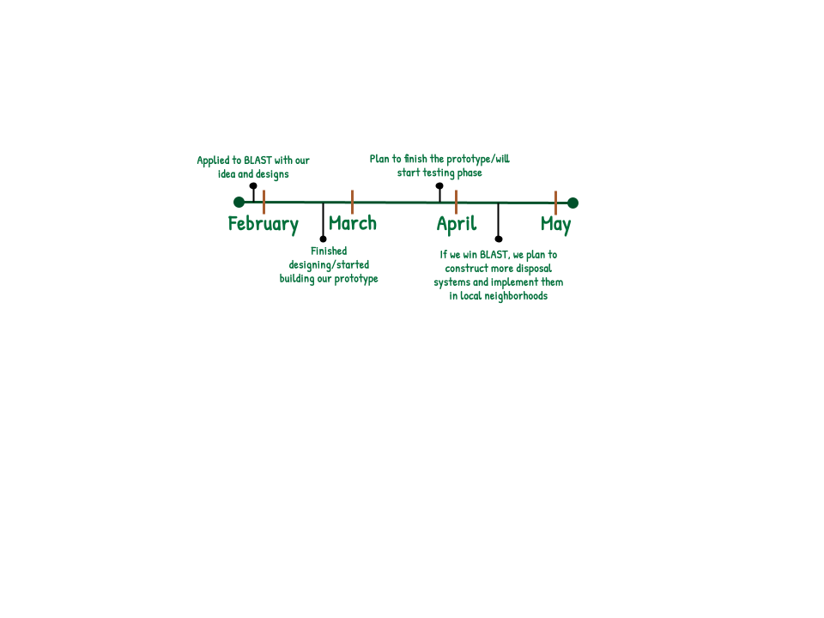
The timeline below shows the progress of our SmokeSmart Disposal system over the months and our plans for the future, even after the BLAST competition.

Goals:
Short Term: Before our pitch in April, we plan to fully finish and modify our prototype to make the device more durable and usable by the public. We will continue to test our system under harsh conditions to ensure our product is ready for public use and severe weather conditions. Additionally, with the help of 3D-printed signs, we aim to make our disposal system more aesthetic to attract more smokers to our product.
Long Term: We are determined to see our cigarette disposal system positively impact our community in the long run. We hope that more smokers will learn of our innovation and use it responsibly. All in all, we want to better the world with our BLAST project, decreasing cigarette pollution in our environment.

Budget:
To make the SmokeSmart Disposal system, we spent $92.39 split between the two of us. At this rate, if our project is selected to receive funding from BLAST, we estimate that we will construct around 10 more of these cigarette disposal bins, which we will then implement in local communities around the Aurora-Naperville Area. Please consult the table attached for the specific costs of materials needed for our project:

SmokeSmart Disposal System Production Costs
Materials/Parts: | Supplier: | Costs (USD):
Extra Heavy 4" T-Hinges | Menard's | $8.86
National Hardware Screw Eyes | Menard's | $0.70
National Hardware Safety Hasp | Menard's | $2.20
Filtration Netting | Amazon | $9.78
Wood (Frame) | Home Depot | $15.78
Olympic WaterGuard Wood Sealer x2 | Home Depot | $13.94
Watts Push-To-Connect 3/4'' Valve | Menard's | $13.34
3/4'' by 5’ CPVC Pipe | Menard's | $5.08
JB WaterWeld Epoxy Putty x3 | Menard's | $16.47
#10 by 2" Wood Screws | Meijer | $1.24
Bucket ( Collect Waste Water) | Walmart | ≈ $5.00
Grand Total: | $92.39

Educational Goals:
We are both passionate about engineering and aspire to pursue careers where we can apply engineering to solve real-world problems. We aim to attend universities and study aerospace/environmental engineering, where we can enhance our knowledge. This BLAST project has helped us gain valuable hands-on experience making a difference in our community. While working on our project, we learned the fundamentals of woodworking and were driven to think of creative solutions to many obstacles we faced, which will benefit our future studies.

